Maharshi Dayanand College of Arts, Science and Commerce
Parel, Mumbai-400012.

Department of Zoology

Webinar on “Mental health and coping during Covid-19”.
Organized by – Zoology Department

Date & Day: 6th June 2020 Time: 4.00 pm

Resource person: Dr. Isha Jalanapurkar, M.D.,
Assistant Professor of Psychiatry and Pediatrics,
University of Massachusetts Medical School.
Details: Dr. Jalanapurkar being an expert in the field of psychology, discussed about psychological issues faced by people and how lockdown has created more of stress among adults and children as well. She conveyed that the way to overcome any mental stress ids through communication, especially at the current situation of pandemic, where everyone is locked inside the doors. To carry out activities within family members to reduce the stress that is building up, etc. She also conveyed the message that staying positive could be key to open up our stress and set our minds free. The session ended up with exchange of Question & Answers in between the participants and our guest speaker.
Number of participants: 69
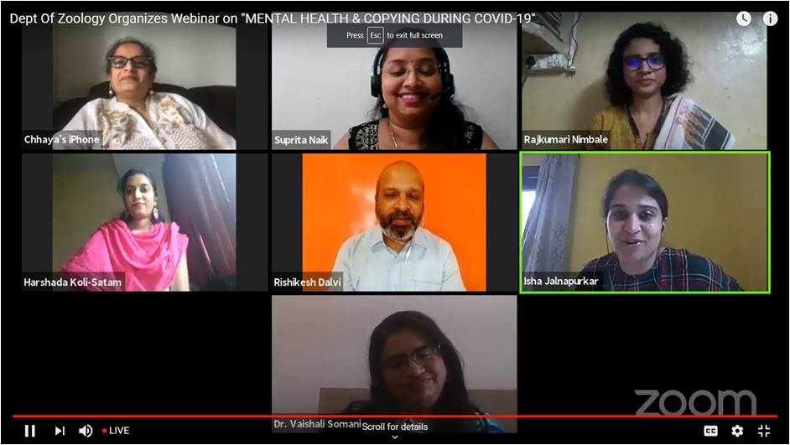

Dr. Isha Jalnapurkar- Webinar on “Mental health and coping during Covid-19”

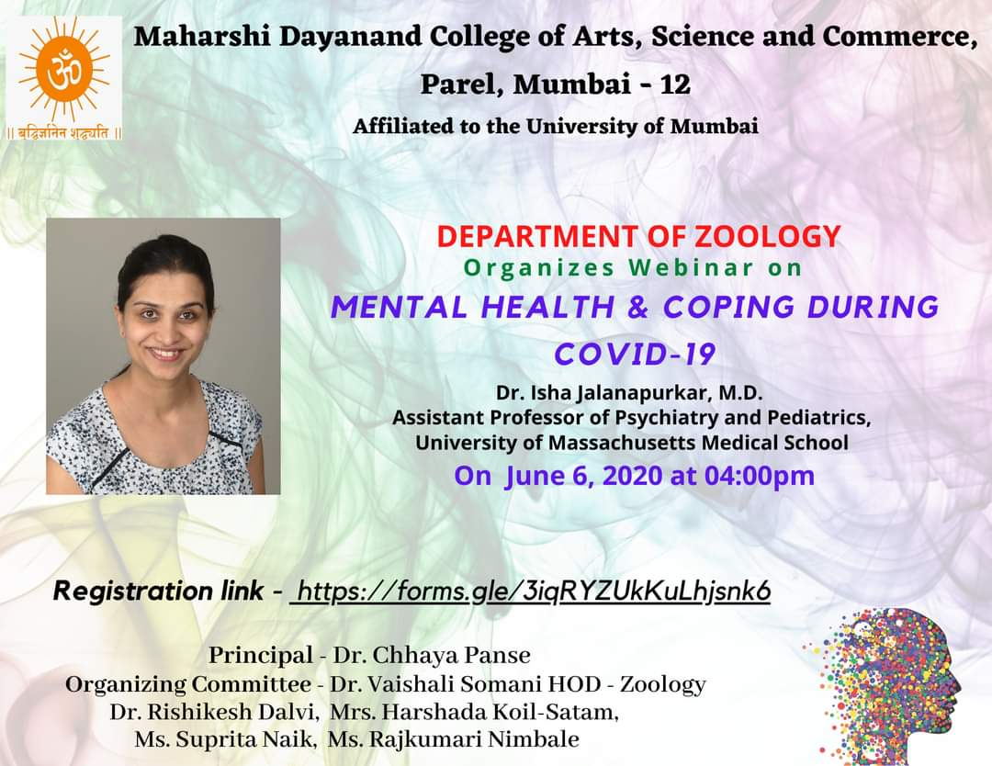
Flyer for the Webinar

