Maharshi Dayanand College of Arts, Science and Commerce
Parel, Mumbai-400012.

Department of Zoology
Title of the Webinar
Concept of Modern Zoo and Role of Zoos in Conservation and Education"
Date, Day and Time: 5th June 2020, 3:00pm (World Environment Day)
Name of Resource Persons:
- Dr. Sanjay Tripathi, Director of Veermata Jijabai Bhosale Udyan and Zoo.
- Dr. Devanand Shirsat, Curator
- Dr. Dipika Valsarajan, Veterinary officer
- Mr. Abhishek Satam, Zoo-Biologist
Collaboration: Veermata Jijabai Bhosale Udyan and Zoo, Byculla, Mumbai.
On the Occasion of World Environment Day on 5th June 2020, Veermata Jijabai Bhosale Udyan and Zoo, Byculla, Mumbai in collaboration with Zoology Department, Maharshi Dayanand College, Parel Mumbai organized a webinar on "Concept of Modern Zoo and Role of Zoos in Conservation and Education". The webinar was telecasted live on YouTube and viewed by large number of students, researchers and Teachers. Dr. Sanjay Tripathi explained basic concept and modernisation of Mumbai Zoo. Dr. Devanand Shirsat discussed about the challenges and the ways of managing them in Covid pandemic situation. Mr. Abhishek Satam acquainted the participants with the enrichment activities conducted for different animals in the zoo. Dr. Dipika Valsarajan described the role of zoo in conservation. The session was useful to create awareness about changes in Zoo and its role in conservation of animals. The students could interact with the experts and expressed their wish to volunteer for various activities which would be organised by the Zoo in future.
No. of participants: 65
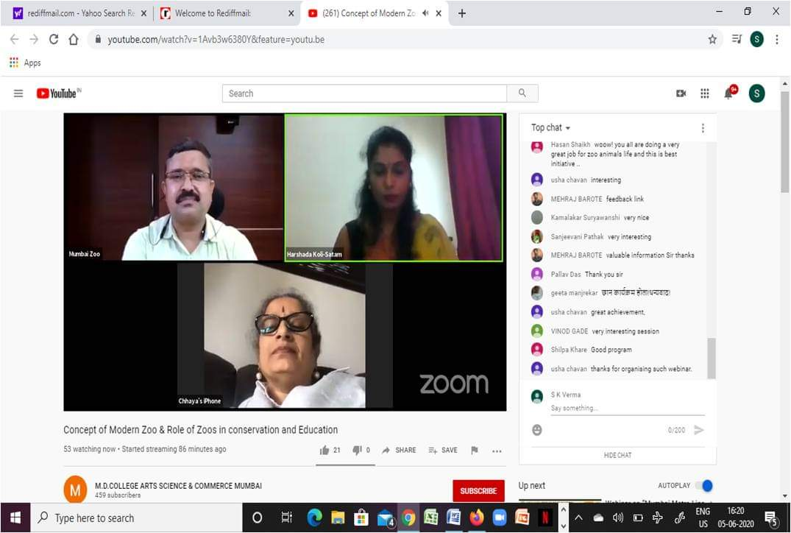
Dr. Tripathi- Director, Veermata Jijabai Bhosale Udyan and Zoo

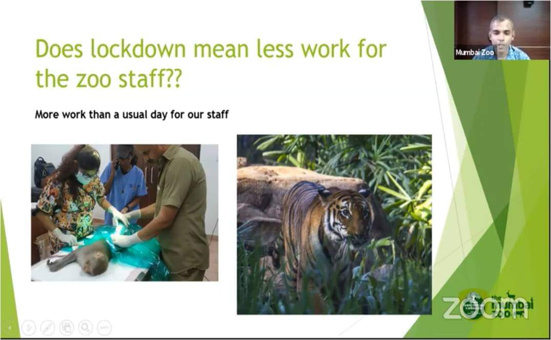
Zoo Biologist Mr. Abishek Satam addressing the participants

Flyer of webinar:

