USZO602,UNIT II
HOMEOSTASIS
Homeostasis (from Greek"hómoios", "similar" and stásis, "standing still"), is the process by which internal conditions are regulated and remain relatively constant.
It is the tendency of an organism or a cell to regulate its internal conditions, usually by a system of feedback controls, so as to stabilize health and functioning, regardless of the outside changing conditions.
Homeostasis in a general sense refers to stability, balance or equilibrium. It is the body's attempt to maintain a constant internal environment. Homeostatic regulation involves three parts or mechanisms: 1) the receptor, 2) the control center and 3) the effector.
The receptor receives information that something in the environment is changing. The control center or integration center receives and processes information from the receptor. And lastly, the effector responds to the commands of the control center by either opposing or enhancing the stimulus. This is an ongoing process that continually works to restore and maintain homeostasis.

STIMULUS---RECEPTOR----INTEGRATION CENTER--EFFECTOR--RESPONSE
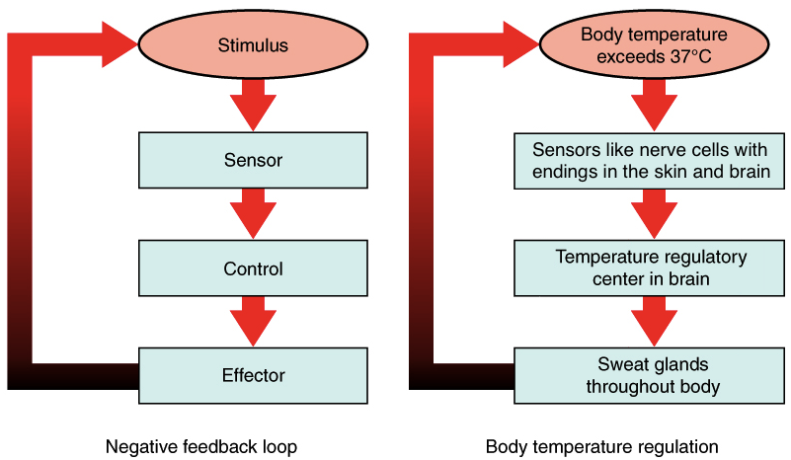
For example, in regulating body temperature there are temperature receptors in the skin, which communicate information to the brain, which is the control center, and the effector is our blood vessels and sweat glands in our skin.
Because the internal and external environment of the body are constantly changing and adjustments must be made continuously to stay at or near the set point, homeostasis can be thought of as a synthetic equilibrium.
All living organisms depend on maintaining a complex set of interacting metabolic chemical reactions. Homeostatic processes act at the level of the cell, the tissue, and the organ, as well as for the organism as a whole.
The nervous andendocrinesystems play an important role in maintaining homeostasis. Recently, it is also believed thatbiological defense systems, such as the immune system, also play a leading role in maintaining homeostasis.
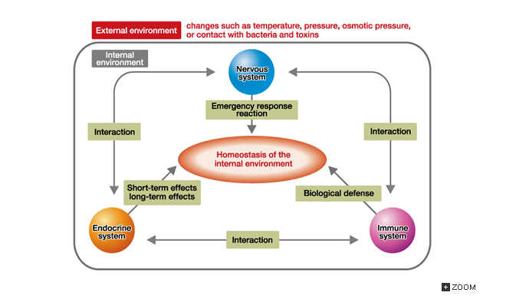

Fig. 5-1 Correlation between the Nervous, Endocrine, and Immune Systems functioning to maintainHomeostasis

Positive and Negative Feedback
- Positive feedback: Is a response to increase the response. Positive feedback is less common in naturally occurring systems than negative feedback. Blood clotting in which the platelets process mechanisms to transform blood liquid to solidify is an example of positive feedback loop. Another example is the secretion of oxytocin which provides a pathway for the uterus to contract, leading to child birth.

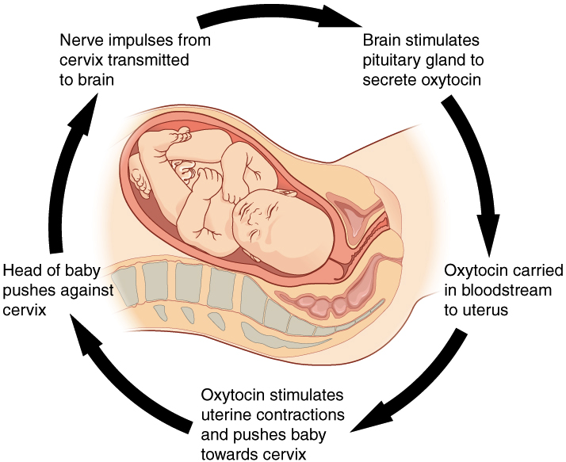

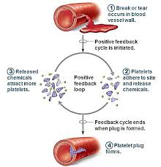

- Negative feedback: if there is any decrease or increase I the process, negative feedback will restore it to its normal range.
- this tends to keep conditions constant, it allows the maintenance of homeostasis. For instance, when the concentration of glucose in the human body increases or decreases, it is restored again to normal value by hormones. Thermoregulation is another example of negative feedback. When body temperature rises, receptors in the skin and the hypothalamus sense a change, triggering a command from the brain. This command, in turn, effects the correct response, in this case a decrease in body temperature.
- 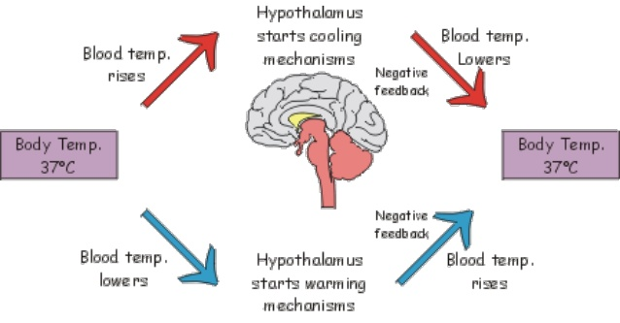
EXTERNAL AND INETRNAL ENVIRONMENT
In 1878, Claude Bernard stated that an organism’s environment is divided into the external environment surrounding an organism and internal environment inside the organism.
Changes in the external environment that affect an organism are widely considered to be stresses such as physical orchemical stresses as well as biological stresses such as exposure to bacteria.
The nervous system exerts the first response against fluctuations in the external environment. Fluctuations in external physical factors are perceived as signals by receptors such as those for temperature, pressure, and osmotic pressure. These signals are then transmitted to the central nervous system by sensory nerves and are quickly regulated by autonomic nerves. However, the endocrine system plays an important role, beyond the role of the nervous system, in maintaining homeostasis. Hormones, which are the messengers of the endocrine system, are of many different types and are immediately secreted to act on environmental changes and provide fortification in order to adapt to new environments over a long period
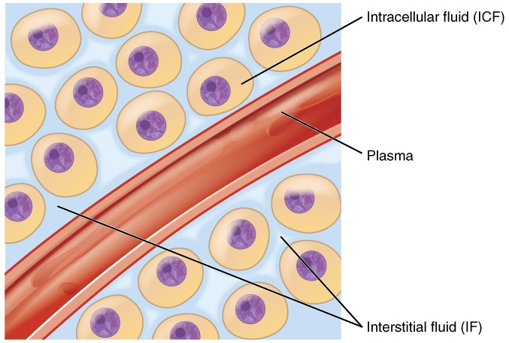
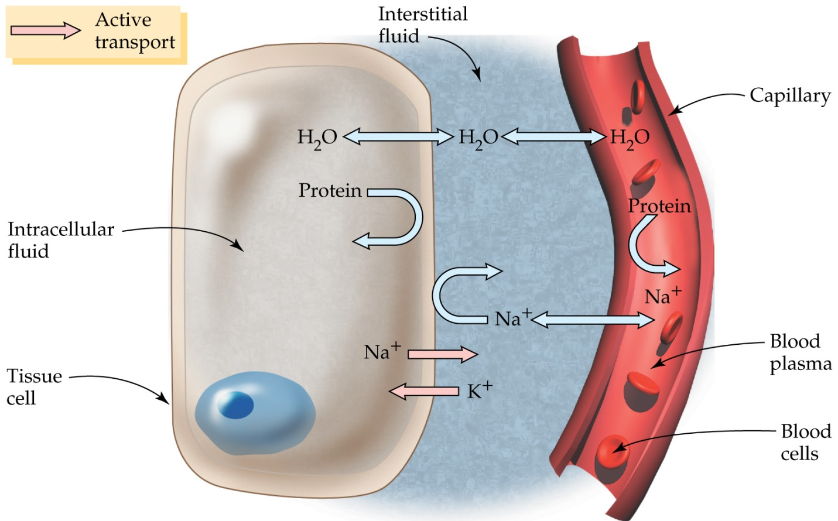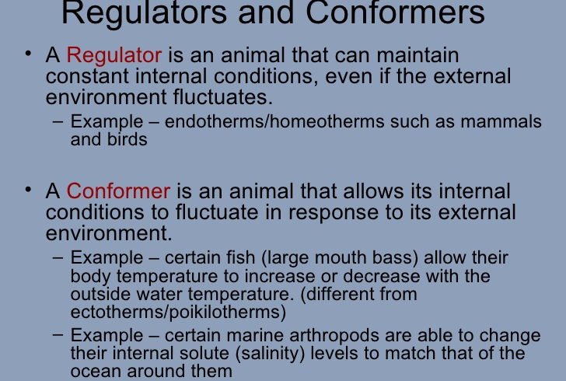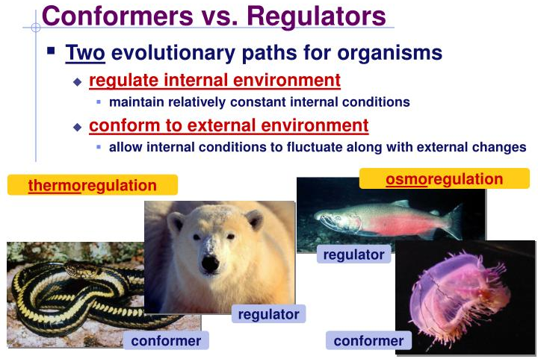

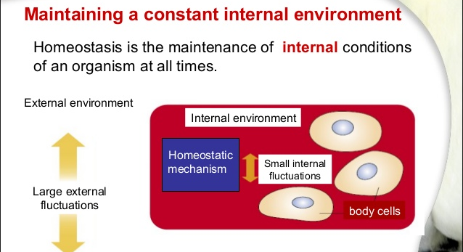
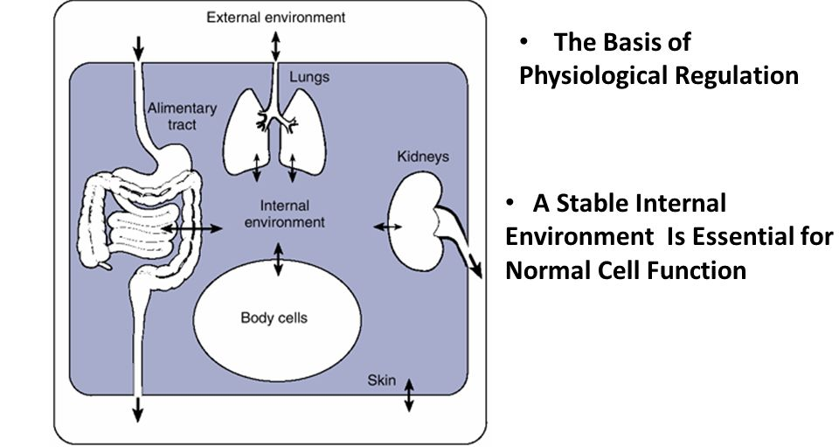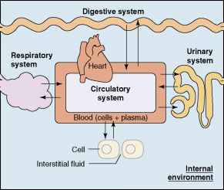

ACCLIMATION AND ACCLIMATIZATION
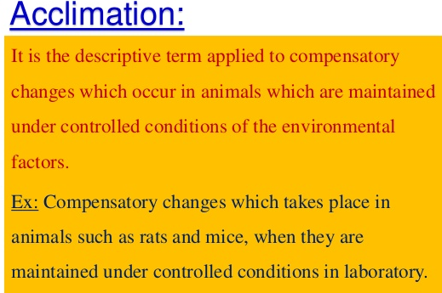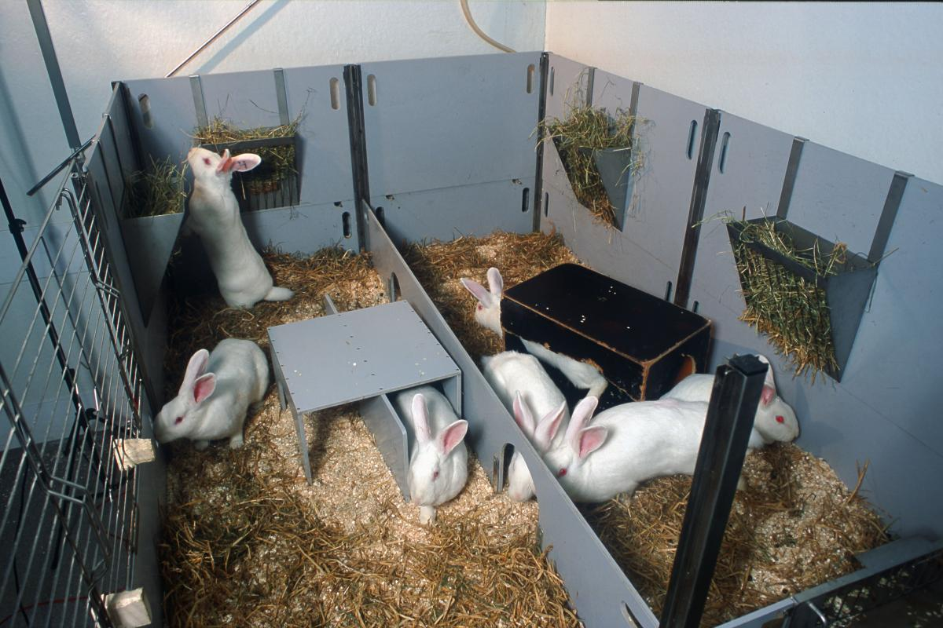
Acclimation involves----changes in – metabolism rate,body functions, enzyme activity and behaviour
e.g. thermal acclimation-COLD ACCLIMATION
when a animal from Normal temp. ta is subjected to cold ta, then there is initial drop in body temp. as shown by position 1. If the animal is exposed to hot environment there is initial rise in body temp. shown by pattern 1. If the body temp (tb) from 1 settles to 0 then the compensation is known as “perfect compensation” & acclimation as “Perfect Acclimation”. acclimation depends on physiological state of animal such as hormonal state, health, injuries etc. • Not only the animals show different type of acclimatory compensation. It is found that in an animal different tissues show different type of acclimatory compensations. In cold acclimation protein & enzyme secretion is more as compared to hot acclimation. When birds or mammals are kept at low temp. in laboratory, initially their body temperature falls down but then they show rise in metabolic rate, rise in O2 consumption. This change is proportional to change in temp. As oxidation is faster, the food intake rises. The enzymes in liver, muscles and mitochondria rise. Glucose, pentose, fatty acid pathways are mobilised. They become faster. Adrenal & thyroid secretion rises. Most important is that the peripheral circulation rises to keep skin warm & in them normally insulation by fur coat does not change.
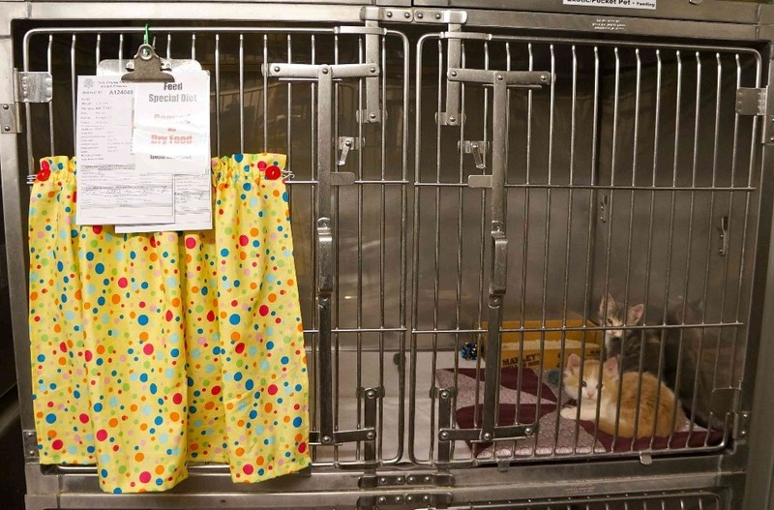
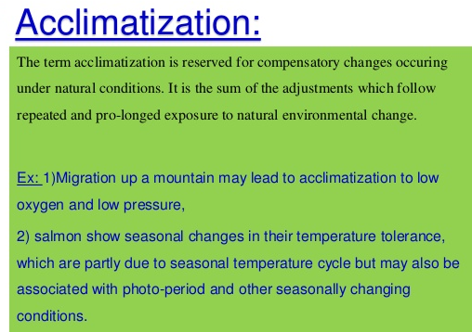
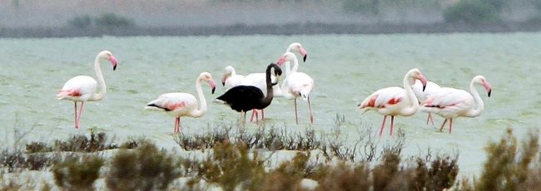
COLD ACCLIMATIZATION
This is a slow process & is seasonal. The change is prolonged & gradual & hence the compensatory changes are different. In nature when change occurs the animal show changes in thickness of fur coat. They reduce the peripheral circulation & both these prevent heat loss. • This is because in environment with approach of winter there is scarcity of food. • It is found that the thickness of fur rises in large animals. • In them fat is mobilised & unsaturated fat gets deposited in joints & extremity so that the flexibility is maintained. • Their CNS, tissue, nerves gradually gain resistance to stand the cold. Sparrow gain resistance at rate 60 drop / month. Sensitivity of tissues is increased . There is higher sensitivity of the tissues to neurotransmitter or the transmittor subs. • Along with these the animal show behavioural changes in them. e.g. Dog, rats, bees show aggregation phenomenon in cold season.
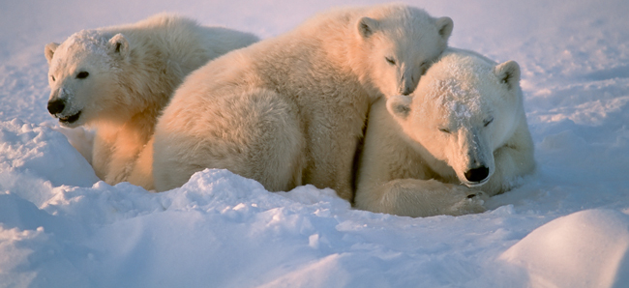
ACCLIMATIZATION OF HIGH ALTITUDE
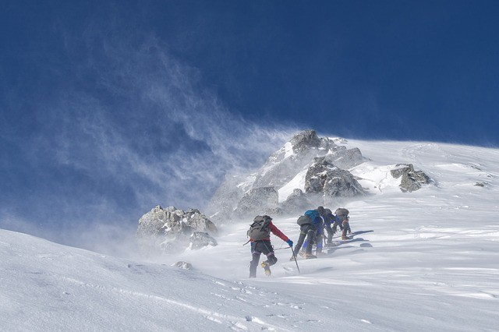
Hyperventilation
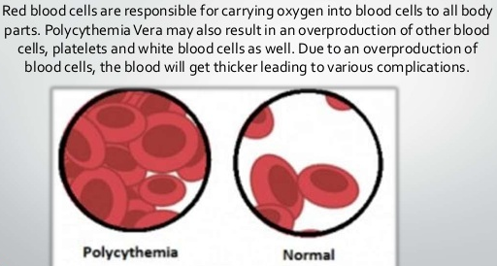
2.1.2 Body clock- 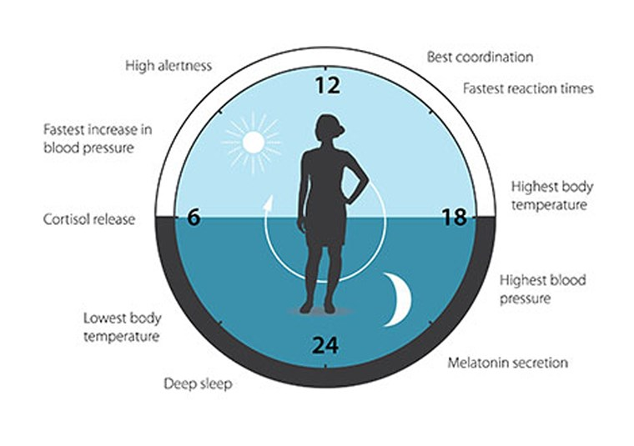
Circadian rhythm
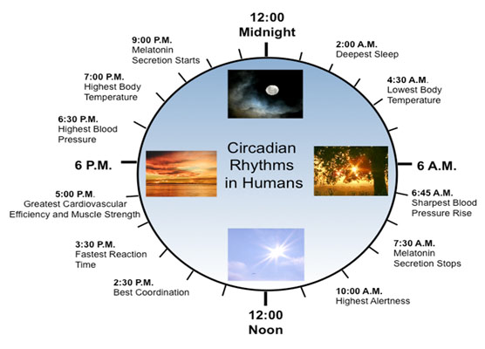
Diurnal rhythms

Thermoregulation is the ability of an organism to keep its body temperature within certain boundaries, even when the surrounding temperature is very different.

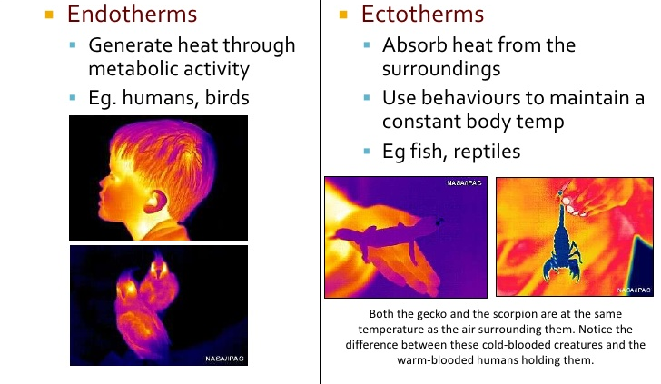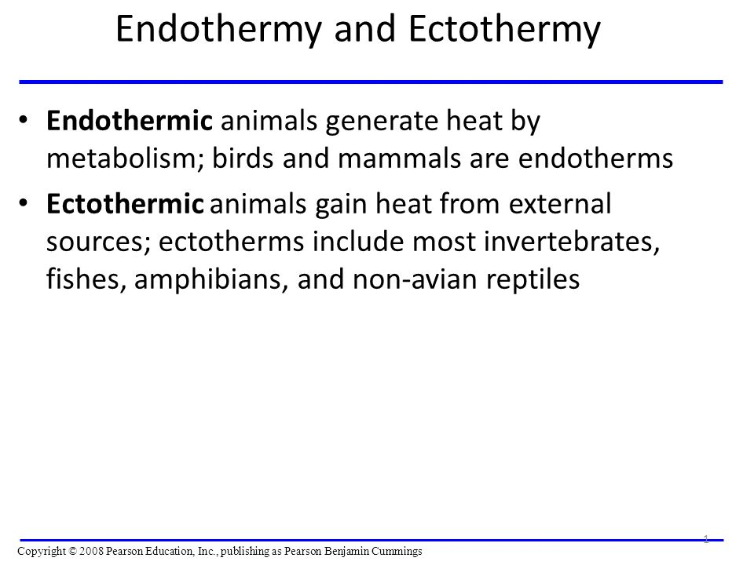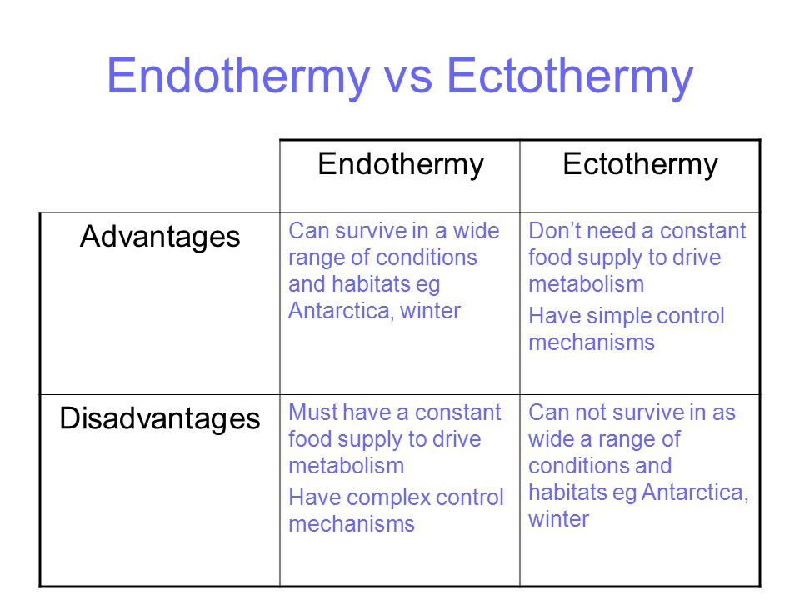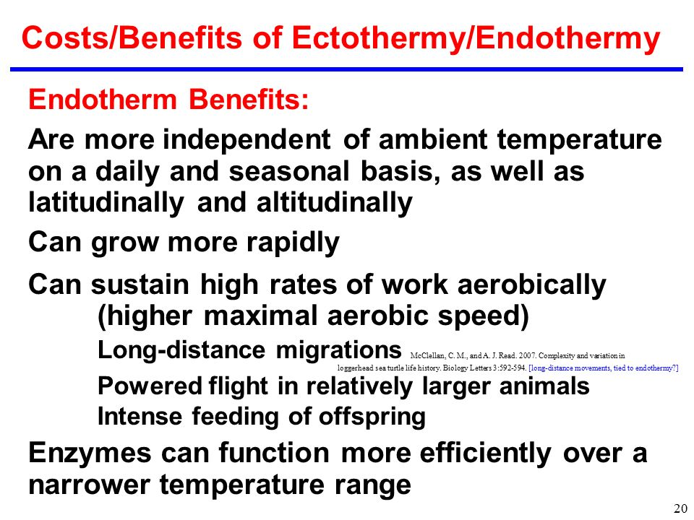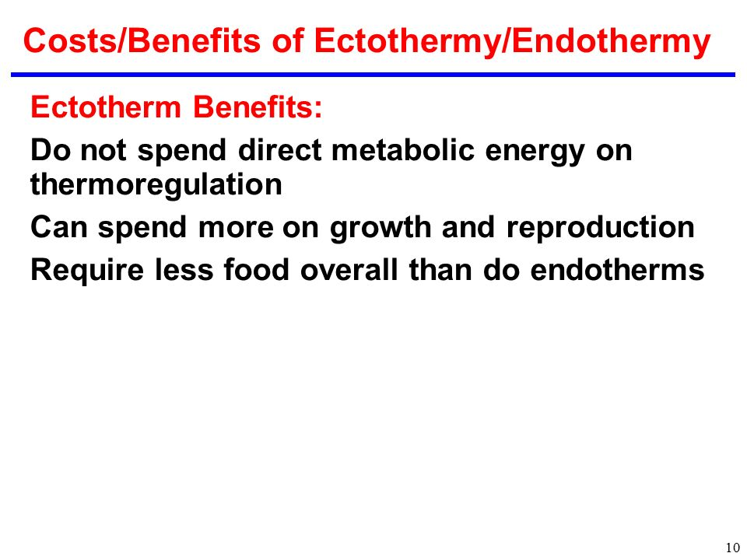

Thermogenesis is the process of heat production in organisms. Shivering thermogenesis is the production of body heat generated by involuntary muscle action during shivering. All mammals and birds have a shivering response, but few reptiles are capable of shivering thermogenesis.
Read more : http://www.ehow.com/facts_6110503_shivering-thermogenesis_.html

Shivering
One method to raise temperature is through shivering. It produces heat because the conversion of the chemical energy of ATP into kinetic energy causing some of the energy to show up as heat. It is not 100% efficient, meaning while some of the energy becomes heat, a portion is transferred to the kinetic energy that produces its characteristic muscular twitches. No productive movement is produced in shivering because antagonistic muscle pairs are simultaneously activated. Shivering is the process by which the body temperature of hibernating mammals (such as some bats and ground squirrels) is raised as these animals emerge from hibernation.

Non-shivering thermogenesis
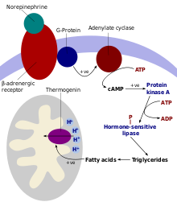
Activation cascade of thermogenin in cells of brown adipose tissue
Non-shivering thermogenesis occurs in brown adipose tissue (brown fat) that is present in all mammals (porcine being the only exception currently known). Brown adipose tissue has a unique protein (uncoupling protein-1) that allows the uncoupling of protons moving down their mitochondrial gradient from the synthesis of ATP, thus allowing the energy to be dissipated as heat.^{[1]}
In this process, substances such as free fatty acids (derived from triacylglycerols) remove purine (ADP, GDP and others) inhibition ofthermogenin (uncoupling protein-1), which causes an influx of H⁺ into the matrix of the mitochondrion and bypasses the ATP synthasechannel. This uncouples oxidative phosphorylation, and the energy from the proton motive force is dissipated as heat rather than producing ATP from ADP, which would store chemical energy for the body's use. Thermogenesis can also be produced by leakage of thesodium-potassium pump and the Ca²⁺ pump.^{[citation needed]} Thermogenesis is contributed to by futile cycles, such as the simultaneous occurrence of lipogenesis and lipolysis or glycolysis and gluconeogenesis.
The low demands of thermogenesis mean that free fatty acids draw, for the most part, on lipolysis as the method of energy production.

Regulation[edit]
Non-shivering thermogenesis is regulated mainly by thyroid hormone and the sympathetic nervous system. Some hormones, such asnorepinephrine and leptin, may stimulate thermogenesis by activating the sympathetic nervous system. Rising insulin levels after eating may be responsible for diet-induced thermogenesis (thermic effect of food).

Definition
  - Derived from the Greek words "therme" (heat) and "genesis" (origin), thermogenesis means the production of heat. Shivering thermogenesis is, therefore, the creation of heat caused by shivering.

Purpose
  - Shivering thermogenesis is used to heat the body when it becomes too cold. Shivering is usually triggered by exposure to cold environmental temperatures, but the "temperature set point" that triggers shivering varies among species and individuals.
  - Sponsored Links
    - Puff Insulation
Cold Insulation, Puff Insulation & Thermal Insulation Service, Mumbai.
smmarineinsulation.com/Enquire_Now

Mammal and Birds
  - Although all mammals and birds can shiver to produce heat, shivering thermogenesis is generally considered an inefficient method to maintain a constant, warm body temperature. Therefore, mammals and birds rely on shivering only as a last resort, when air or water temperatures are too low to rely solely on other pathways of metabolic heat production.

Reptiles
  - Females of several species of large-bodied pythons use shivering thermogenesis to heat their eggs during brooding. After laying eggs, a female gathers her eggs and curls tightly around them, insulating them from environmental temperatures. She then shivers using coordinated muscle contractions to heat her eggs above background environmental temperatures, when temperatures are below her preferred set point.

Non-shivering Thermogenesis
  - Non-shivering thermogenesis is the production of metabolic heat without shivering, and is caused by diet and muscle activity during movement. Non-shivering thermogenesis is the primary pathway for heat production in mammals and birds, and is more efficient than shivering thermogenesis. Shivering is only used as a last resort, once an individual has exhausted the ability to generate metabolic heat. Non-shivering thermogenesis is used less in reptiles and only contributes substantially to body heat in the largest reptile species, such as Leatherback Sea Turtles.

Brown adipose tissue (BAT) or brown fat is one of two types of fat or adipose tissue (the other being white adipose tissue, or white fat) found in mammals.
It is especially abundant in newborns and in hibernating mammals.^{[1]} Its primary function is to generate body heat in animals or newborns that do not shiver. In contrast to white adipocytes (fat cells), which contain a single lipid droplet, brown adipocytes contain numerous smaller droplets and a much higher number of (iron-containing) mitochondria, which make it brown.^{[2]} Brown fat also contains more capillaries than white fat, since it has a greater need for oxygen than most tissues.
The function of brown adipose tissue is to transfer energy from food into heat; physiologically, both the heat produced and the resulting decrease in metabolic efficiency can be of significance. Both the acute activity of the tissue, i.e., the heat production, and the recruitment process in the tissue (that results in a higher thermogenic capacity) are under the control of norepinephrine released from sympathetic nerves. In thermoregulatory thermogenesis, brown adipose tissue is essential for classical nonshivering thermogenesis (this phenomenon does not exist in the absence of functional brown adipose tissue), as well as for the cold acclimation-recruited norepinephrine-induced thermogenesis. Heat production from brown adipose tissue is activated whenever the organism is in need of extra heat, e.g., postnatally, during entry into a febrile state, and during arousal from hibernation, and the rate of thermogenesis is centrally controlled via a pathway initiated in the hypothalamus. Feeding as such also results in activation of brown adipose tissue; a series of diets, apparently all characterized by being low in protein, result in a leptin-dependent recruitment of the tissue; this metaboloregulatory thermogenesis is also under hypothalamic control. When the tissue is active, high amounts of lipids and glucose are combusted in the tissue. The development of brown adipose tissue with its characteristic protein, uncoupling protein-1 (UCP1), was probably determinative for the evolutionary success of mammals, as its thermogenesis enhances neonatal survival and allows for active life even in cold surroundings.
http://www.ncbi.nlm.nih.gov/pubmed/14715917

The word thermogenesis means the process of heat production in organisms. When adults are cold, they shiver. Shivering results to increased muscle activity, thus, producing heat. In newborns these mechanisms of heat production do not occur. Newborns rarely shiver except at very low temperatures. Shivering is not an effective way of producing heat in the youngest population.
Nonshivering thermogenesis is the primary method of heat production in infants. It is NOT shivering that produces heat but the metabolism of brown fat increases body temperature when the thermal receptors in the skin detect a skin temperature of 35 to 36 degree Celsius (95 to 96.8 degree Fahrenheit).
Brown Fat
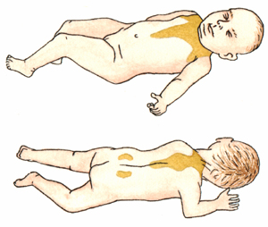
location of brown fats in newborns
Brown fat, also called adipose tissue or brown adipose tissue (BAT), is a special kind of highly vascular fat found in newborns. It contains an ample supply of blood vessels which cause the brown color. Brown fats are located primarily in the following areas:
- Back of the neck
- In the axillae
- Around the kidneys
- Adrenals
- Sternum
- Between the scapulae
- Along the abdominal aorta
Some infants have insufficient brown fat stores. Preterm infants may be born before the stores of brown fat have accumulated. Aside from the said case, intrauterine growth restriction also deplete brown fat stores before birth occurs. Newborns that are exposed to prolonged cold stress may have insufficient brown fat stores as large amount brown fat is consumed for heat production in this situation. Thus, these infants will not be able to raise their body temperature if they are subjected to further episodes of cold stress. Without brown fat to be metabolized, no heat production will counteract the cold stress. Hence, the infant is at risk to serious complications.
Processes Involved in Nonshivering Thermogenesis
- Nonshivering thermogenesis begins when the thermal receptors in the skin detect a skin temperature of 35 to 36 degrees Celsius (95 to 96.8 degrees Fahrenheit).
- The thermal receptors stimulation is then transmitted to the hypothalamus thermal center.
- In response to the hypothalamic stimulation, norepinephrine is released in brown fat.
- Presence of norepinephrine in the brown fat initiates its metabolism.
- As brown fat is metabolized, it generates more heat than other fats.
- Thus, blood passing through the brown fats is warmed and carries heat to the systemic circulation or to the rest of the body.

- Vaporization:
  - Evaporation of sweat and other bodily fluids.
- Convection:
  - Increasing blood flow to body surfaces to maximize heat loss.
- Conduction:
  - Losing heat by being in contact with a colder surface. For instance:
    - Lying on cool ground.
    - Staying wet in a river, lake or sea.
    - Covering in cool mud.
- Radiation:
  - releasing heat by radiating it away from the body.

n hot conditions[edit]
A dog panting after exercise
- Eccrine sweat glands under the skin secrete sweat (a fluid containing mostly water with some dissolved ions), which travels up the sweat duct, through the sweat pore and onto the surface of the skin. This causes heat loss via evaporative cooling; however, a lot of essential water is lost.
- The hairs on the skin lie flat, preventing heat from being trapped by the layer of still air between the hairs. This is caused by tiny muscles under the surface of the skin called arrectorpili muscles relaxing so that their attached hair follicles are not erect. These flat hairs increase the flow of air next to the skin increasing heat loss by convection. When environmental temperature is above core body temperature, sweating is the only physiological way for humans to lose heat.
- Arteriolar vasodilation occurs. The smooth muscle walls of the arterioles relax allowing increased blood flow through the artery. This redirects blood into the superficial capillaries in the skin increasing heat loss by convection and conduction.
Note: Most animals cannot sweat efficiently. Cats and dogs have sweat glands only on the pads of their feet. Horses and humans are two of the few animals capable of sweating. Many animals pant rather than sweat because the lungs have a large surface area and are highly vascularised. Air is inhaled, cooling the surface of the lungs and is then exhaled losing heat and some water vapour.

Thermoregulation in hot and humid conditions[edit]
In general, humans appear physiologically well adapted to hot dry conditions.^{[12]} However, effective thermoregulation is reduced in hot, humid environments such as the Red Sea and Persian Gulf (where moderately hot summer temperatures are accompanied by unusually high vapor pressures), tropical environments, and deep mines where the atmosphere can be water-saturated.^{[12][7]} In hot-humid conditions, clothing can impede efficient evaporation.^{[8]} In such environments, it helps to wear light clothing such as cotton, that is pervious to sweat but impervious to radiant heat from the sun. This minimizes the gaining of radiant heat, while allowing as much evaporation to occur as the environment will allow. Clothing such as plastic fabrics that are impermeable to sweat and thus do not facilitate heat loss through evaporation can actually contribute to heat stress.

acclimation
To accustom or become accustomed to a new environment or situation; adapt.physiological adjustment by an organism to environmental change.
Acclimatization (UK also acclimatisation; US also acclimation) is the process in which an individual organism adjusts to a gradual change in its environment (such as a change in temperature, humidity, photoperiod, or pH), allowing it to maintain performance across a range of environmental conditions. Acclimation occurs in a short period of time (days to weeks), and within the organism's lifetime (compare to adaptation). This may be a discrete occurrence or may instead represent part of a periodic cycle, such as a mammalshedding heavy winter fur in favor of a lighter summer coat. Organisms can adjust their morphological, behavioral, physical, and/or biochemical traits in response to changes in their environment.^{[1]} While the capacity to acclimate to novel environments has been well documented in thousands of species, researchers still know very little about how and why organisms acclimate the way that they do. When used as a technical term (such as in the study of physiology), acclimatization refers to a natural process (e.g., shedding heavy winter fur with natural seasonal change), whereas the term acclimation is reserved for changes occurring in response to an artificial or controlled situation, such as changes in temperature imposed in an experimental manipulation.
Acclimation:
Physiological adaptations that occur through experimentally induced stressors.
E.g. Exercising in a heat chamber
Acclimatization:
Physiological adaptations that occur from natural environmental stressors
E.g. Exercising in a humid environment

“Hibernation” is defined as a state of inactivity over an extended period. By this definition, the term can be applied to a myocardium (heart muscle) that has become dysfunctional, or even a computer that is “sleeping” but not completely turned off.
The definition as applied to animals, however, should be referable to physiological response to environmental change. Most people are aware that when an animal sleeps (the response) through winter (the environmental change), it is, in effect, hibernating. Physiologically, “sleep” is a state of reduced activity of muscle and nerve function accompanied by reduced cell metabolism; that is, reduced chemical reactions in the body cells.
Specifically, hibernation is sleep and also:
- a response to weather conditions
- accompanied by a substantial decline in body temperature; and
- generally measured in months or seasonality rather than hours.
By these criteria, human sleep is clearly not hibernation; nor is a bear (despite popular belief) that “sleeps” through winter, hibernating because its body temperature is decreased only slightly (6°C). Many true hibernators can depress their body temperature by more than 30°C.

Hibernation Versus Aestivation
When hibernation is induced by events other than winter, the term “aestivation” is commonly applied instead. Aestivation, however, can be shorter than winter hibernation because environmental conditions (dry and/or hot spells) that bring about the physiological state are often less predictable. Snails aestivate during the hot hours of the day, but the lungfish may aestivate for years buried in dried-up lakes.
Both “hibernation” and “aestivation” can be interchangeable with “dormancy”, which is inactivity over a long period of time. When a snake is hibernating, it is basically in a state of dormancy. Dormancy in insects that hibernate through winter, during which their growth and development are suspended, is termed “diapause”.

Ectotherms and Endotherms
Snails, lungfish, insects, snakes (which are reptiles), and frogs (amphibians) are ectotherms, meaning their body temperature increases when the environmental temperature is high but decreases when cold outside. When the external temperature is low for a long period, an ectotherm could become inactive for the duration of that (that is, hibernate) because low body temperatures decrease the body’s enzyme activity, resulting in minimal muscle movement.
Mammals and birds are endotherms that can maintain a constantly high body temperature despite changes in the surrounding temperature. A healthy human, for instance, maintains a body temperature of 37°C regardless of whether it is hot or cold outside. Endotherms can do this because metabolizing cells in their body produce a sufficient amount of heat. Cell metabolism in ectotherms does not produce enough heat for body-temperature maintenance.

Torpor and Adaptive Hypothermia
“Torpor” occurs when body temperature, metabolic rate, and other body functions are markedly lower than the normal condition of a given animal species. Hibernation, aestivation, and dormancy are simply a prolonged form of torpor.
Unlike ectotherms which are reliant on increasing external temperature to emerge from torpor, endotherms use internal heat production to arouse from torpor. This ability allows many endothermic species to enter torpor for less than a day, instead of months. This is known as “daily torpor”. Many small mammals and birds use this strategy to their advantage in variable environments.
In all cases, because cell metabolism requires energy, a reduction in metabolic rate is a measure to save energy. Not all animals can save energy this way because a lowered body temperature causes hypothermia, which for many species (human is an example) is lethal if prolonged. Torpor is “adaptive hypothermia” because survival in animals adopting this physiological condition is not negatively affected but is in fact enhanced.

